## Online Bus Reservation System Site

The audit of the open source code found that SQL injection existed, and the Bus_id parameters were not filtered.

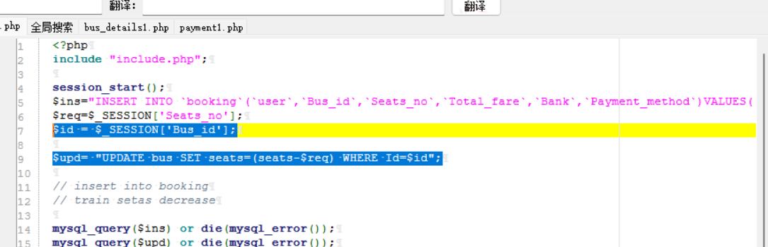

Therefore, the Bus_id was tracked and discovered

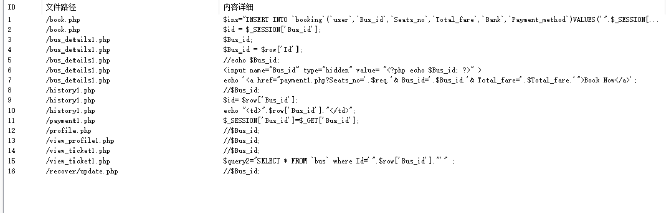

Therefore, the request bus_details1.php is captured, and the following packets are found to have Bus_id variables

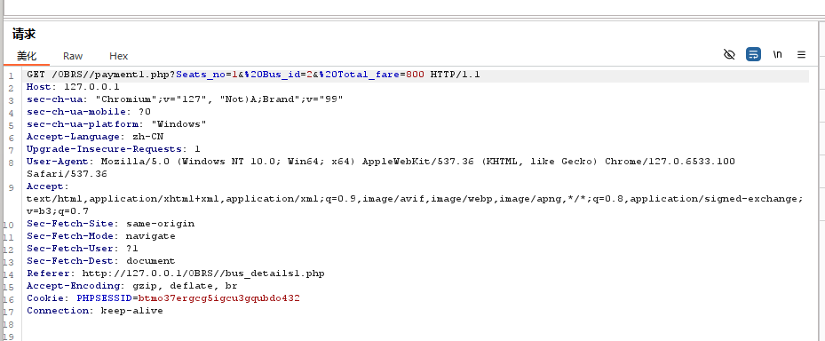

So it can be injected here.

So modify the request header /OBRS//payment1.php? Seats_no=1&%20Bus_id=2'&%20Total_fare=800 found that the web page is inaccessible, so there is an injection at this point.

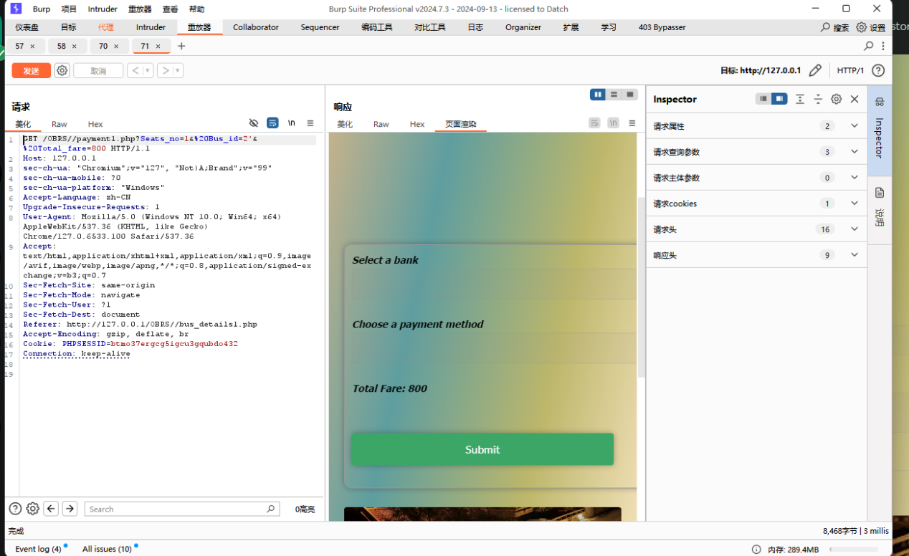

Normal web page access is as follows:

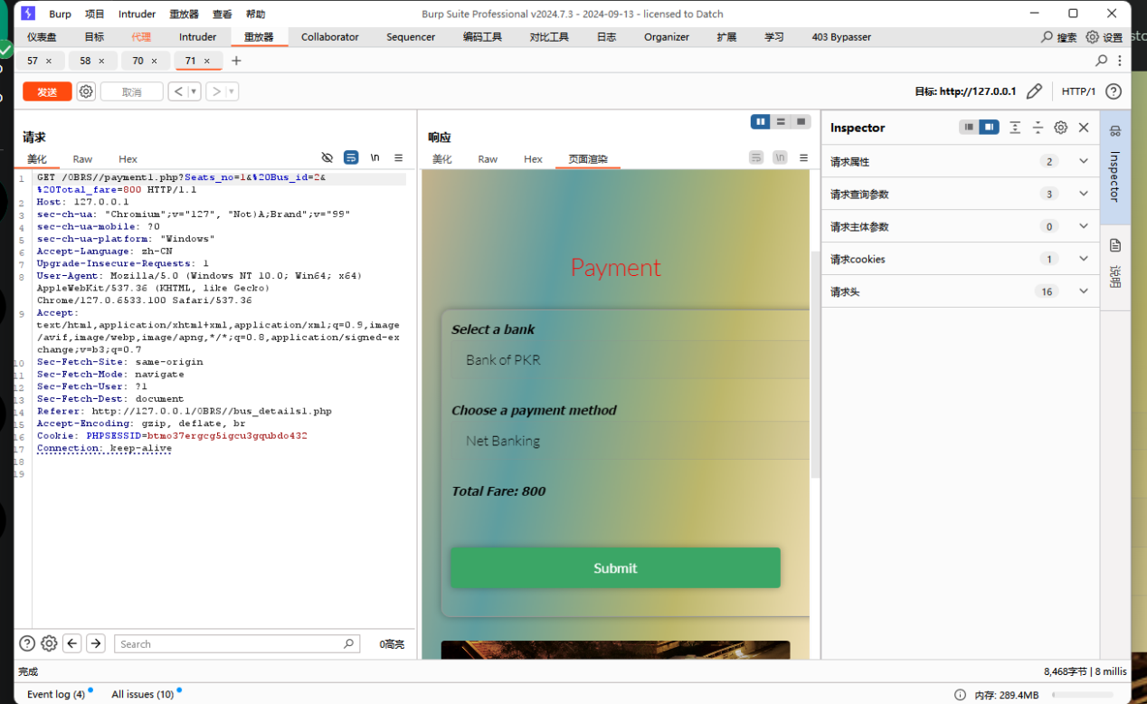

Modify the code:

<?php

include "include.php";

session_start();

$user = $_SESSION['user'];

$bus_id = $_SESSION['Bus_id'];

$seats_no = $_SESSION['Seats_no'];

$total_fare = $_SESSION['Total_fare'];

$bank = $_POST['Bank'];

$payment_method = $_POST['Payment_method'];

$conn = new mysqli($host, $username, $password, $dbname);

if ($conn->connect_error) {

die("Connection failed: " . $conn->connect_error);

}

$ins = $conn->prepare("INSERT INTO booking (user, Bus_id, Seats_no, Total_fare, Bank, Payment_method) VALUES (?, ?, ?, ?, ?, ?)");

$ins->bind_param("ssssss", $user, $bus_id, $seats_no, $total_fare, $bank, $payment_method);

if (!$ins->execute()) {

die("Error executing insert query: " . $ins->error);

}

$upd = $conn->prepare("UPDATE bus SET seats = seats - ? WHERE Id = ?");

$upd->bind_param("ii", $seats_no, $bus_id);

if (!$upd->execute()) {

die("Error executing update query: " . $upd->error);

}

$ins->close();

$upd->close();

$conn->close();

$_SESSION['pay'] = 'Payment successful...';

header('location: generic.php');

exit();

?>